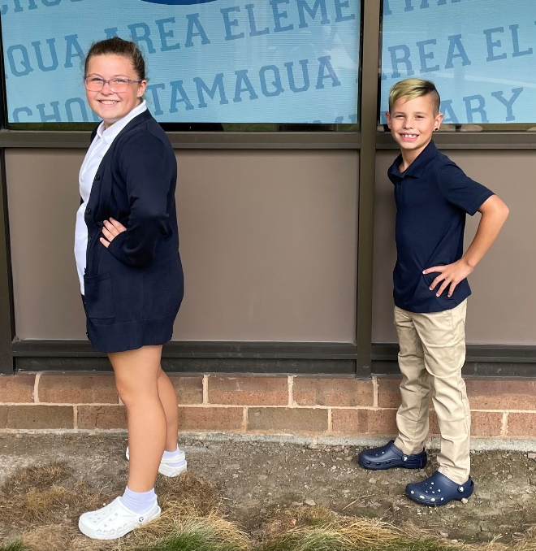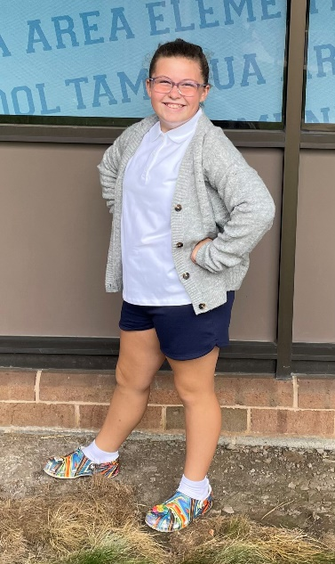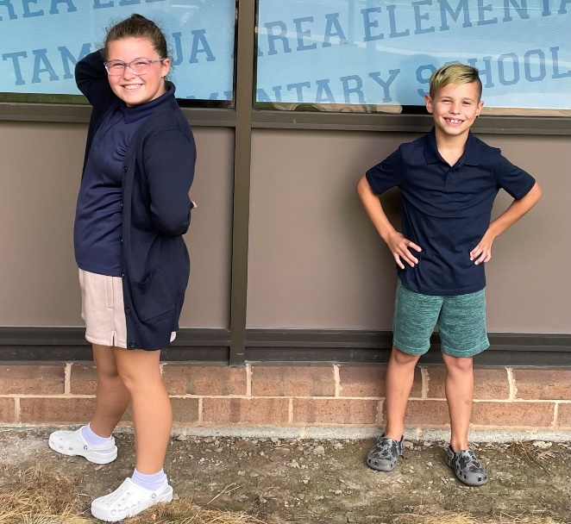

*The arrows give examples of items that are not representative of the approved Tamaqua Area School District dress-code.

Ready for school

**Elementary School Dress Code Examples**

Sweater color

Shoe color

Hoodie

Hoodie

Cargo pants

Shorts color

Shoe color

Shoe color